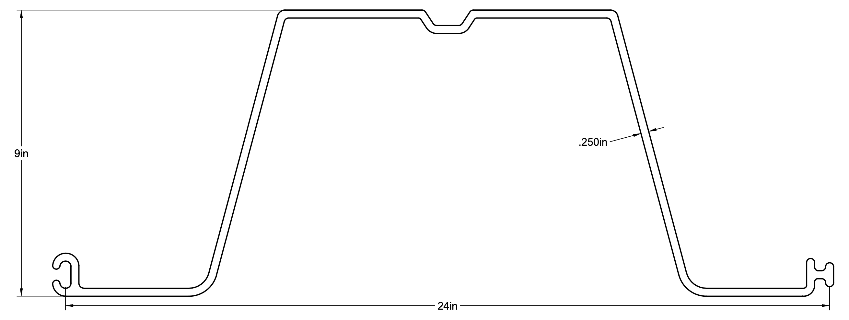
Attribute | Imperial |  | Metric
 | Value | Unit | Value | Unit
Allowable Moment (M_allow) | 6937.50 | ft-lb/ft | 9.41 | kN·m/m
Section Modulus (Z) | 11.10 | in³/ft | 181.90 | cm³/m
Moment of Inertia (I) | 39.00 | in⁴/ft | 1623.34 | cm⁴/m
Span (L) | 8.00 | ft | 2.44 | m
Uniform Load (w) | 250.00 | plf | 3648.48 | N/m
Max Moment (M_max) | 24000.00 | lb-in/ft | 2712.00 | N·m/m
Bending Stress (σ) | 2162.16 | psi | 14.91 | MPa
Stress Utilization | 0.14 |  | 0.14
Deflection (δ, E) | 1.07 | in | 27.28 | mm
L/δ | 89.38 |  | 89.38
Thickness (t) | 0.25 | in | 6.35 | mm
Section Depth | 8.00 | in | 203.20 | mm
Section Width | 24.00 | in | 609.60 | mm
Ultimate Tensile Stress | 9000.00 | psi | 62.05 | MPa
Material | Engineered Fiber-reinfocecd Rigid PVC
Profile | Box
UV Stabilized | Yes
Co-Extruded | Yes
